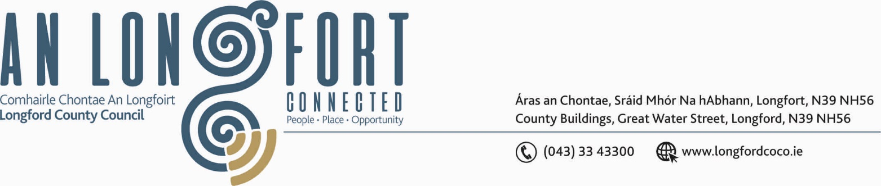

LONGFORD MUNICIPAL DISTRICT

Please note meeting will be held in Longford Rugby Club and via Microsoft Teams.

19th November 2020.

To: Each Member of Longford Municipal District.

Dear Member,

You are requested to attend Meeting of Longford Municipal District to be, held in
Longford Rugby Club, Demesne, Longford on Wednesday, 25th November 2020 at
4.30 p.m. to transact business, as set out on the Agenda hereunder.

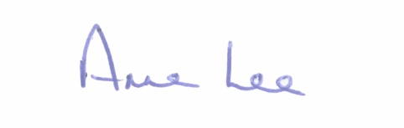
Yours sincerely,

_______________
Anne Lee,
Meetings Administrator.

AGENDA

Prayer before meeting.

- Confirmation of Minutes of meetings of Longford Municipal District held on
the 28th October 2020 - copy enclosed

- Matters arising from Minutes.

- Declaration of Interest by Members.

- Management Report – to follow.

- Keep Well Campaign.

- To note Supplementary Standing Orders – Remote Meetings – adopted at November meeting of Longford County Council – enclosed.

- Notices of Motions, submitted by Councillors, as listed hereunder –

Councillor John Browne.

“I request Longford County Council to write to Transport Infrastructure Ireland , calling for public lighting to be put in place along the footpath on N4 bypass at Longford between the Leo Casey roundabout and the Red Cow roundabout, a distance of 1.3 Kilometres. The location is used extensively by walkers in daylight hours, however it has no night use, because of the lack of public lighting.”

Councillor Gerry Warnock.

“I am requesting Longford Municipal District that when reinstating the speed ramps following completion of works at Blindman’s Walk (Connolly Crescent Stretch) that we upgrade the integrity of the existing ramps on the roadway adjacent to Bannon Terrace and Templemichael Terrace. These ramps have degraded to the extent that they are nearly flush with the road, and residents have noticed a very significant increase in speeding as a result of these diminished deterrents”

Councillor Seamus Butler.

“That the Members of Longford Municipal District request the Strategic Infrastructure and Climate Change SPC to reconsider the charges proposed for the Columbarium Wall plots to reflect the lower land usage and upkeep, by differentiating them from the new grave plot charges.”

Councillor Uruemu Adejinmi.

“For Park Close and Kennedy Drive footpaths to be added to the work plan for Teffia
Footpath works in 2021.”

“Outdoor play is fundamental to enhancing childrens’ quality of life, enabling
development, learning, flexibility, and resilience. I call on the Council to provide a
playground in Mac Eoin Park Estate. This amenity would serve the Estates in and
around Mac Eoin Park.”



